Week 8 GOAL’s

Group Task.
Note: Group Tasks should be completed in groups of two or individually. Under no circumstances are groups of three or more permissible.
Task: Consider the ORDER table below and the determinacy diagram:

Order ID | Product ID | Customer  ID | Customer Name | Depot ID | Depot Location | Unit Price | Quantity
001 | P116 | C001 | John Perry | DP1 | Hendon | 599 | 1
001 | P058 | C001 | John Perry | DP1 | Hendon | 29 | 2
002 | P231 | C002 | Andy King | DP2 | Dover | 449 | 1
002 | P058 | C002 | Andy King | DP2 | Dover | 29 | 3
003 | P231 | C003 | Peter Elton | DP1 | Hendon | 449 | 1
004 | P079 | C004 | Simon Nash | DP3 | Reading | 89 | 2
004 | P231 | C004 | Simon Nash | DP3 | Reading | 449 | 1

You will be marked on the following GOALs:

- G8.1 Determinacy Diagram.

Draw the determinacy diagram for the above data. State any assumption that you make.

My G8.1:
Determinacy diagram:
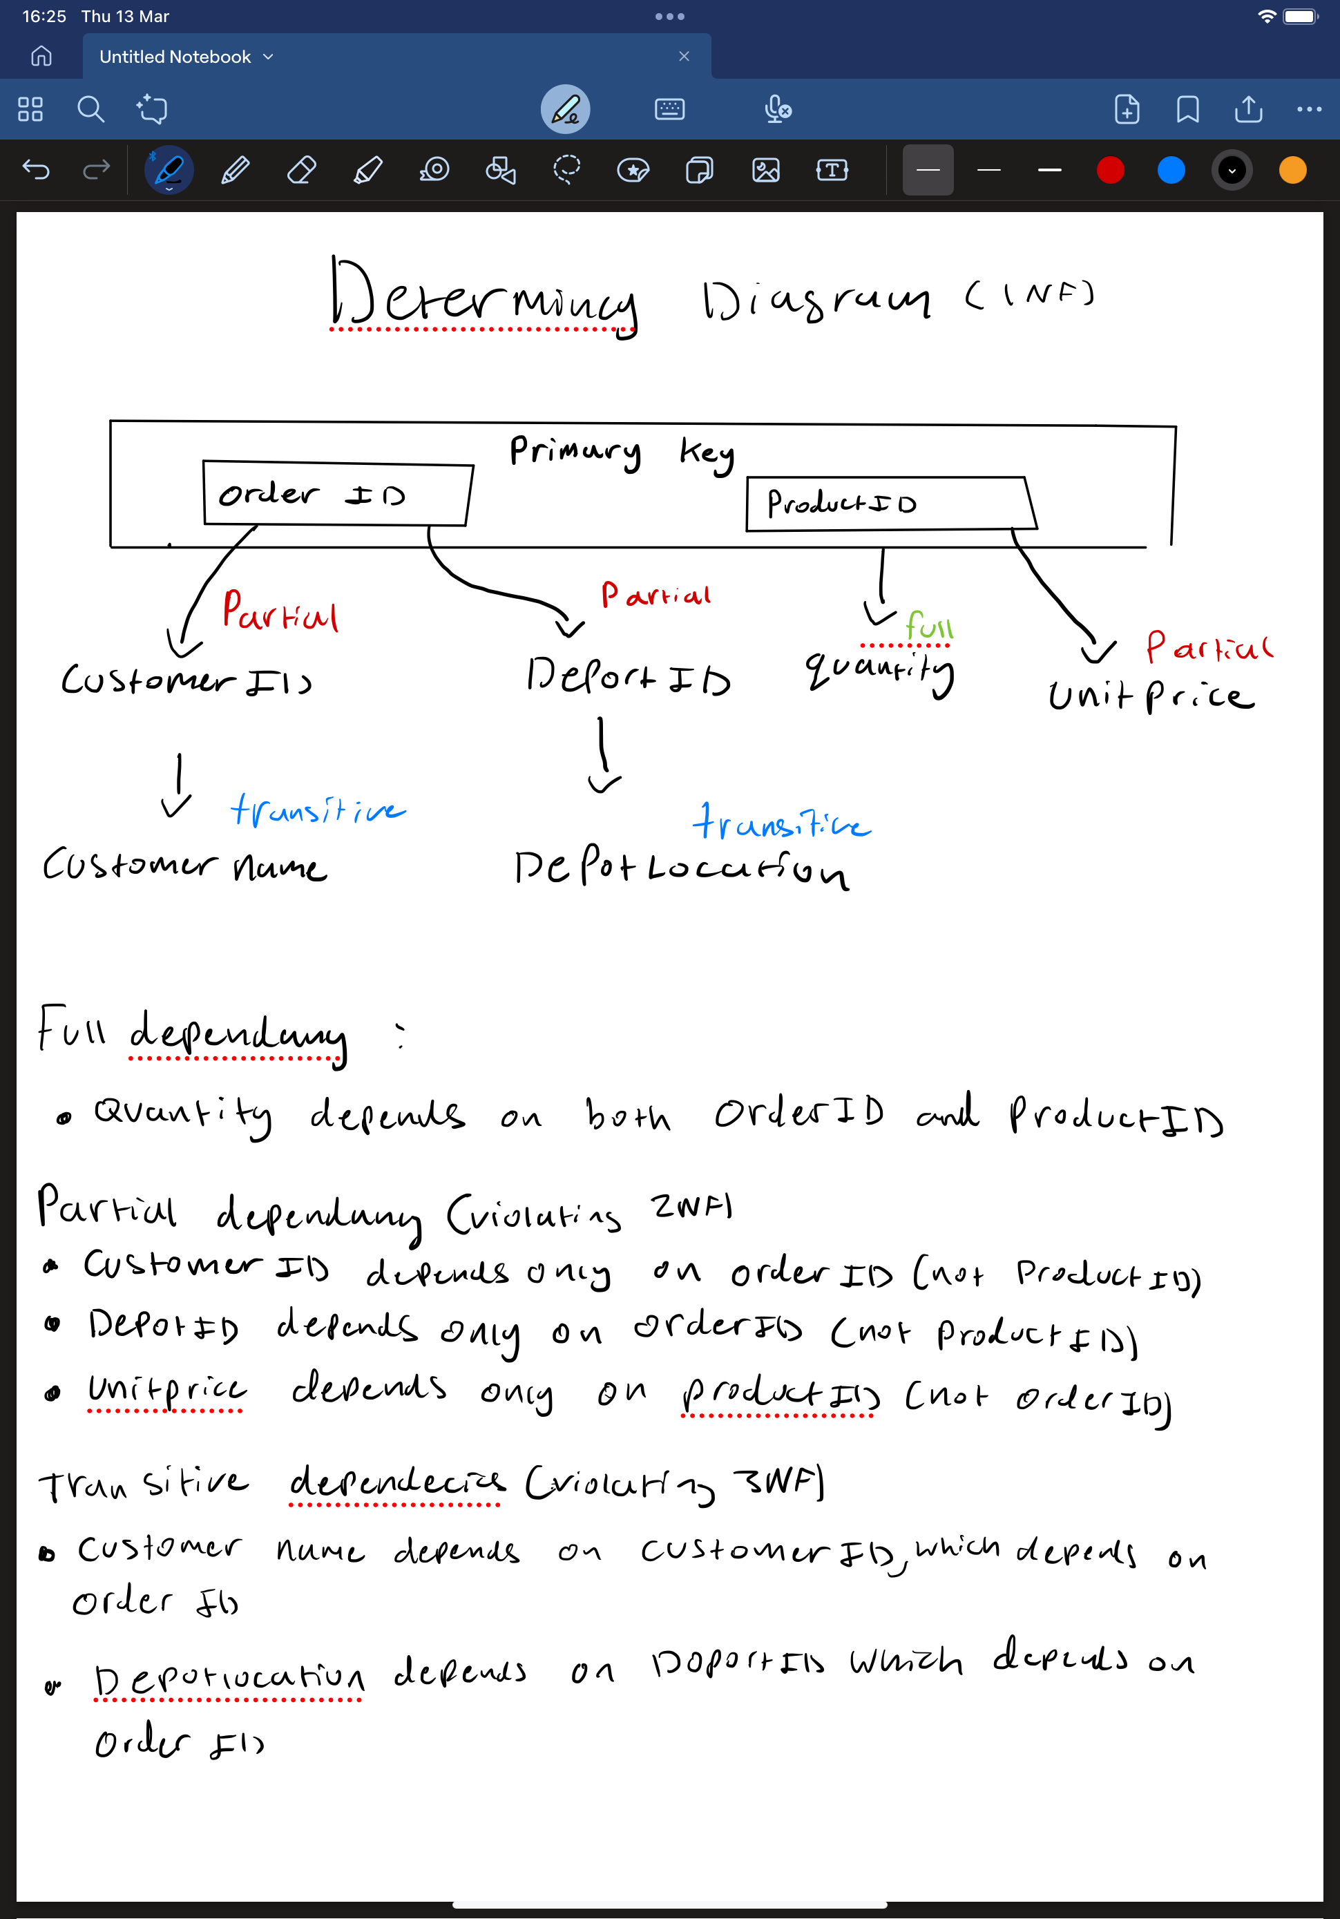

- G8.2 Normalisation.

Convert the 1st Normal Form determinacy diagram created into:
- 2nd Normal Form.
- 3rd Normal Form.

For each normal form, clearly discuss the procedure followed. i.e., How do you move from one Normal Form to another.

My G8.2:

1NF 2NF:
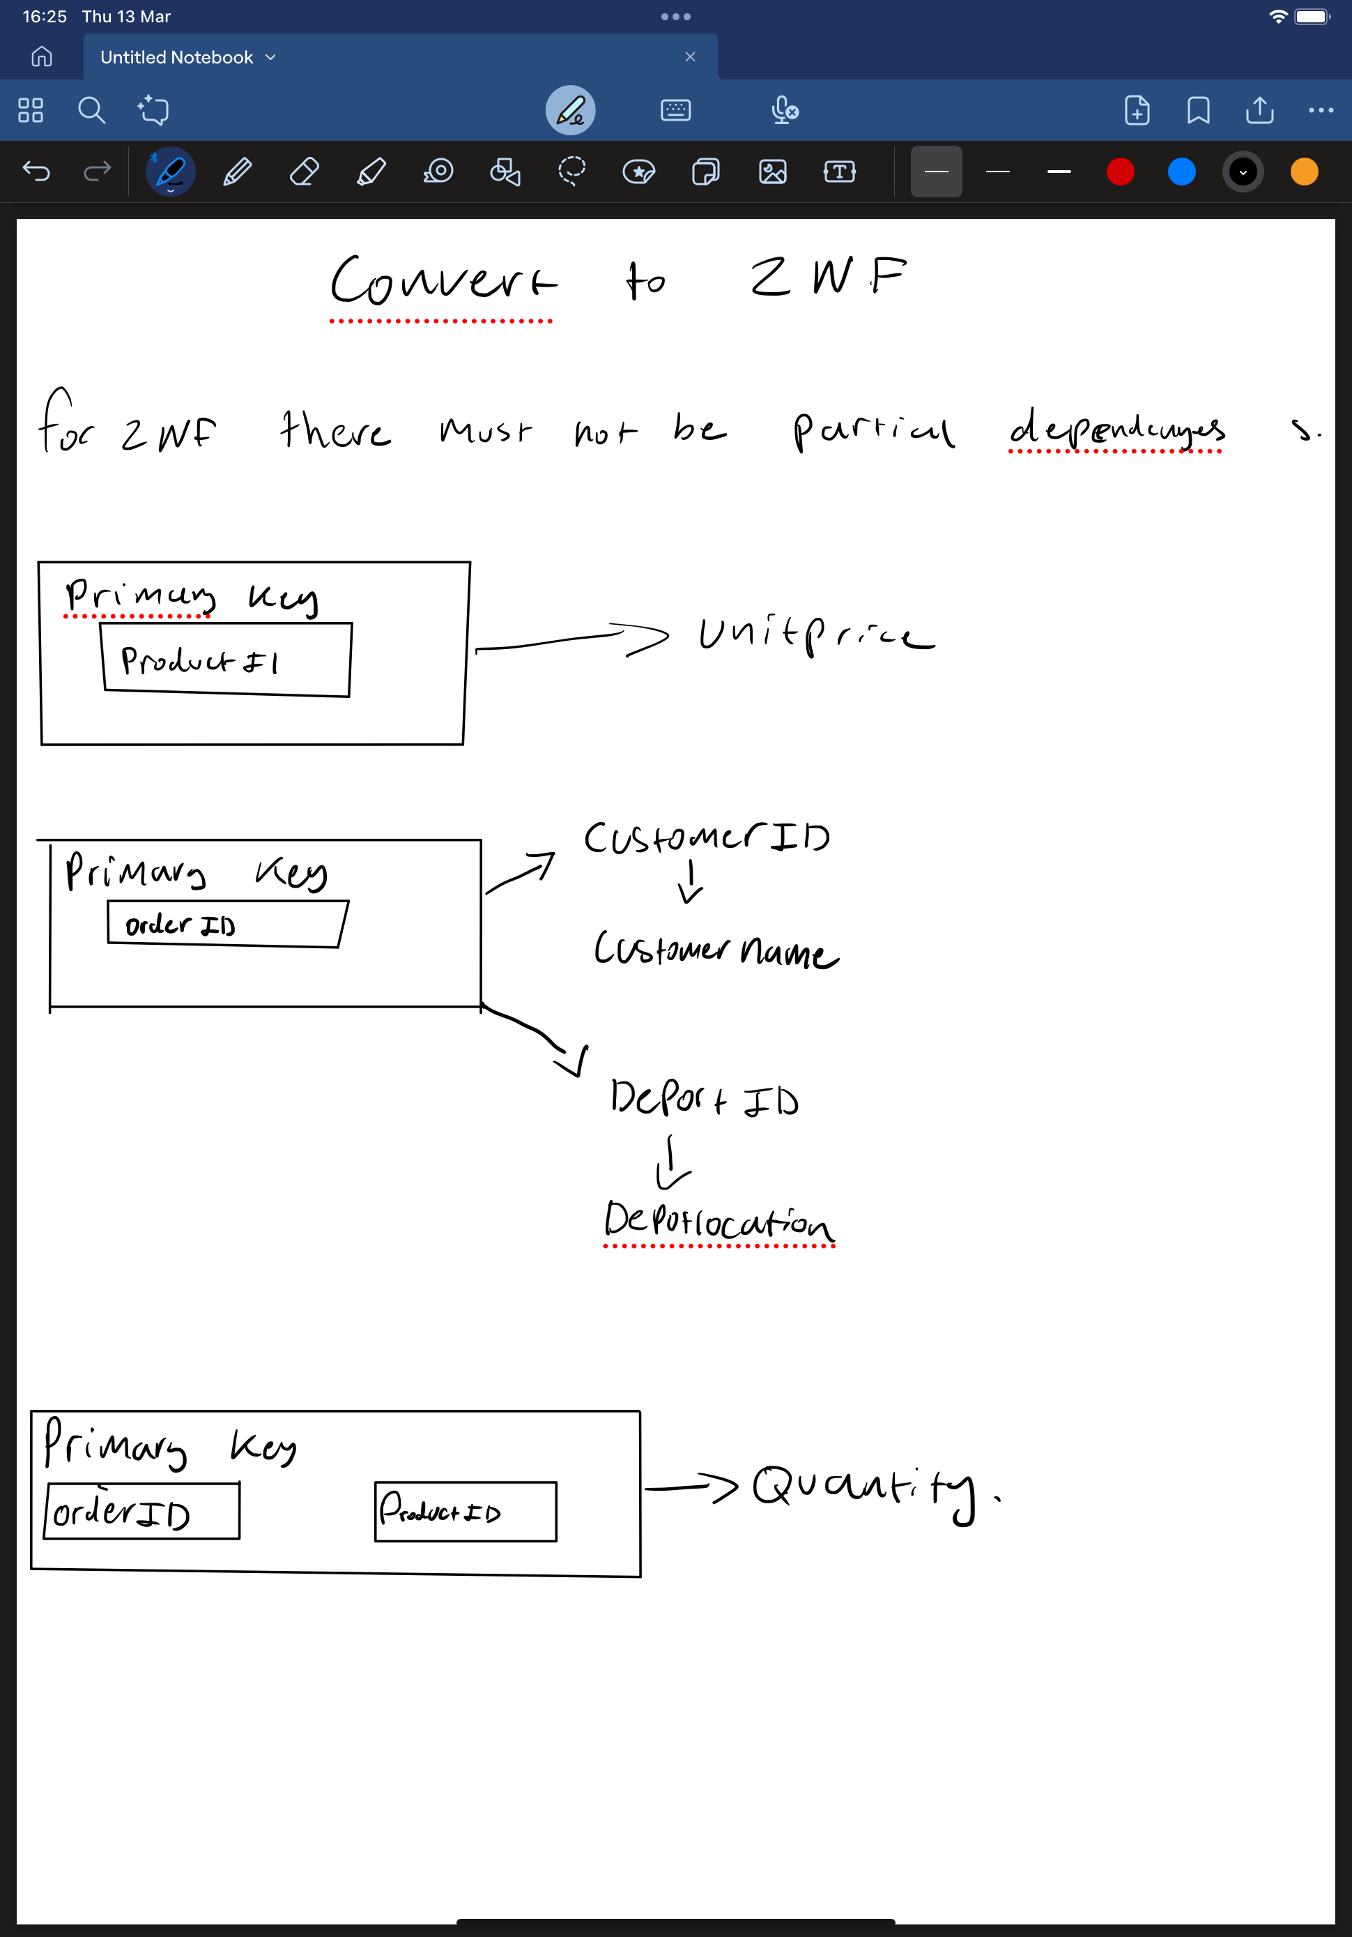

How I converted 1NF to 2NF:

I identified and removed partial dependencies, where some attributes depended only on part of a composite primary key rather than the whole key. In 1NF, attributes like Customer ID and Depot ID depended only on Order ID, while Unit Price depended only on Product ID, meaning they were not fully functionally dependent on the entire primary key. I we ensured that all non-key attributes were fully dependent on their respective primary keys, thus achieving 2NF.

2NF 3NF:
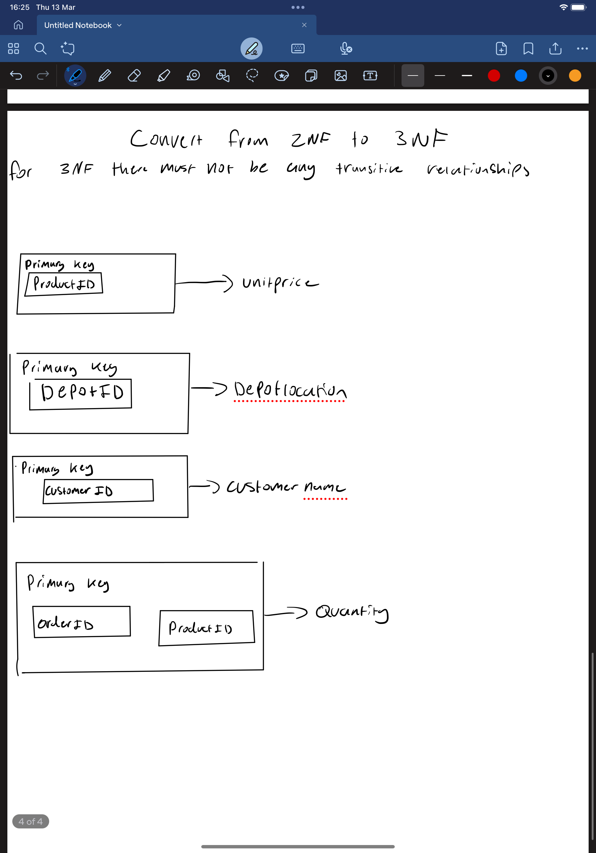

How I converted 2NF to 3NF:

we identified and removed transitive dependencies, where non-key attributes depended on other non-key attributes instead of directly depending on the primary key. In 2NF, attributes like Customer Name depended on Customer ID, and Depot Location depended on Depot ID. Since Customer ID and Depot ID were not primary keys in the order table, these dependencies violated 3NF. I ensured that all non-key attributes now directly depend on their respective primary keys, eliminating transitive dependencies and achieving 3NF.

